IT2010 – Mobile Application Development

BSc (Hons) in Information Technology

2nd Year

Faculty of Computing

SLIIT

**2023 – Assessment 01**

**Phase 1 Report**

|  |  |  |
| --- | --- | --- |
| **Description** | **Student ID** | **Name** |
| Group Leader | IT21169380 | Thuduwage I.M.H.G |
| Member 2 | IT21189944 | Madusanka G.K.I |
| Member 3 | IT21186042 | Ekanayaka E.M.D.K.L |
| Member 4 | IT21169144 | Karunarthne R.Y.D |

|  |  |
| --- | --- |
| **Application Topic** | **Reduce Poverty in Rural SriLanka** |
| **Group Name** | **Neighbourly – Y2.S2.IT.04.01** |

Contents

Project Declaration 4

Introduction 5

Contribution 6

1. IT21169380 – User Profile and Donations 6

2. IT21189944 – Item Donations 6

3. IT21186042 – Family 6

4. IT21169144 – Article 7

User Interfaces 8

1. IT21169380 – User Profile and Donations 8

2.Login 8

1. Main UI 8

3. Sign UP 9

4.Dashboard 9

6. Donate 10

5.Menu 10

8.Fund Overview 11

7.Donation Info 11

9.User Profile 12

10.Edit/Delete Profile 12

12.User List 13

11.Reset Password 13

IT21189944 – Item Donations 14

2.Donation List 14

1.Item Donation 14

4.Donation Done 15

3.Donation Home 15

6.Donation 1 16

5.Donation Category 16

8.Donation 3 17

7.Donation 2 17

9. Donation 4 18

IT21186042 – Family 19

2.Edit Family 19

1.Add Family 19

4.Delete Family 20

3.Contact Us 20

5.About Us 21

IT21169144 – Article 22

2.Edit/ delete Article 22

1.Add Article 22

4.Article 23

3.View/edit Article 23

5.Article List 24

Usage Of Resources 25

Strings xml 25

IT21169380 – User Profile and Donations 25

IT21186042 – Family 28

IT21169144 – Article 29

Colors XML 30

Dimensions 30

Styles XML 31

# Project Declaration

We, the members of “Neighbourly – Y2.S2.IT.04.01”. hereby declare that our group project is entirely authentic and original. We have conducted thorough research and analysis to ensure that our work is not plagiarized or copied from any other sources.

We have followed all guidelines provided by our LIC and have complied with all ethical and academic standards.

We take full responsibility for the authenticity of our work and understand the implications of academic dishonesty. We have worked collaboratively to produce this project, and each member has contributed to the best of their abilities.

We hereby affirm that our project represents our honest effort and commitment to academic integrity, and we take pride in presenting it as our own.

|  |
| --- |
|  |
| Group Leader (Signature)  Thuduwage I.M.H.G |

# Introduction

Neighbourly is a mobile application built using Kotlin language aimed at reducing poverty in rural Sri Lanka and helping people in economic crises. The app connects volunteers and donors, where volunteers can sign up and provide their details, including their National Identity Card (NIC) for verification. Donors can donate money or items, such as food, school accessories, and medical items. Also, Donors can choose specific categories such as child orphanages, elder houses, low-income families, and low-facility schools for their fund donations. The donor dashboard displays the total fund amount, daily money donations, the donor's donations made in all time, as well as the donation overview for each category. Donors and volunteers can edit or delete their accounts.

The app also has a blog with a news page that offers awareness and information, where admin can post, edit, or delete articles. Volunteers can add selected low-income families in their area, and anyone can donate their remaining or prepared food for those families, reducing food wastage and hunger simultaneously. The system sends notifications to relevant volunteers to connect the donated food with those in need. The "Contact Us" page allows users to contact the team with any inquiries or concerns, and inquiries are directed to the relevant parties via email. Neighbourly provides a platform to make a positive impact on people's lives and communities in need.

Neighbourly plans to enhance the app's functionality by adding a volunteer delivery system for those who are unable to collect the available items. The app also aims to connect with the government health sector and register local officers such as Public Health Inspectors (PHI) to obtain key info about people in a given area, such as their BMI values, number of children, and monthly income, in order to prioritize the areas that require the most help and support.

Neighbourly is a non-profit app that supports its operations through advertising from item sellers, pharmacies, food cities, restaurants, and shops. With its noble purpose and innovative features, Neighbourly has the potential to make a significant impact on poverty reduction and create a more equitable and inclusive society in Sri Lanka.

# Contribution

## 1. IT21169380 – User Profile and Donations

There are three types of users in this user management system: volunteers ,donors and Admin. Both can register, log in, update, and delete accounts. Donors can view their donation history, daily donations, and overall fund amounts, while volunteers can view articles and donations in addition to add a family to their account. Only Admins can see the add or delete article options. Users create a username and password during registration and receive a confirmation email. The system allows users to manage their accounts, access information, and make donations in a secure and convenient manner.

Donors can choose the donation their preferred donation category. In this part I will create the Donation form and store donation details.

## 2. IT21189944 – Item Donations

Donors must log into their accounts and select the item donation option before being prompted to fill out a form with the appropriate information. Donors will receive a thank you letter and an email confirming their donation once the form is submitted.

In addition to the donor, all volunteers involved in the charity organization will also receive a notification about the donation. This ensures that everyone is aware of the incoming donation and can take necessary action accordingly.

Volunteers will then update the status of the donation to "dispatched" after it has been distributed, and subsequently delete the item from the donation list. This ensures that there is no confusion or duplication in the distribution process.

## 3. IT21186042 – Family

The charity's app includes a "Add Family" button where volunteers can quickly add recognized families. All that's required is the completion of a form with basic information about the family, including names, addresses, and the kind of help they need.

Additionally, volunteers have the ability to update or delete the added details in the list as needed. This allows for flexibility and ensures that the information is always accurate and up to date.

## 4. IT21169144 – Article

This function allows the administrator of a platform to create and publish articles that provide valuable information about various topics related to helping people in need, crisis situations, and ways to support those who are struggling. The administrator can also update, delete, and manage the list of articles available on the platform. By doing so, the platform can provide volunteers and donors with up-to-date information about relevant issues and guide them towards effective ways of making a difference in their communities. Ultimately, this function can help create a more informed and engaged user base, leading to greater impact in addressing social and humanitarian issues.

# User Interfaces

Drive Link for Android studio UI Screenshots with design view and layout validations - <https://drive.google.com/drive/folders/1p9x39Px6Lk8AhBFbSZuubSIhwalPx2fJ?usp=share_link>

Git Hub Repo Link - <https://github.com/IsuruX98/MAD_Project_Neighbourly.git>

## 1. IT21169380 – User Profile and Donations

### 2.Login

### 1. Main UI

### 3. Sign UP

### 4.Dashboard

### 6. Donate

### 5.Menu

### 8.Fund Overview

### 7.Donation Info

### 9.User Profile

### 10.Edit/Delete Profile

### 12.User List

### 11.Reset Password

## IT21189944 – Item Donations

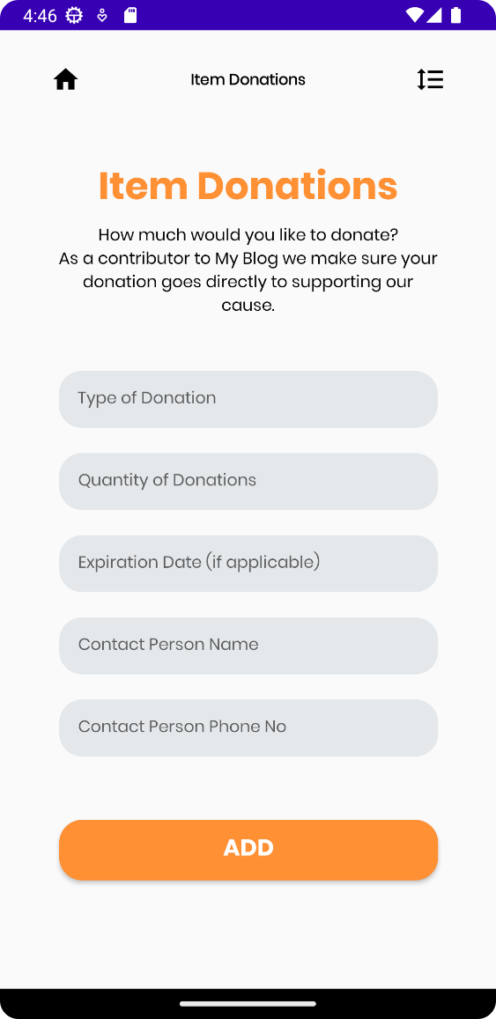

### 2.Donation List

### 1.Item Donation

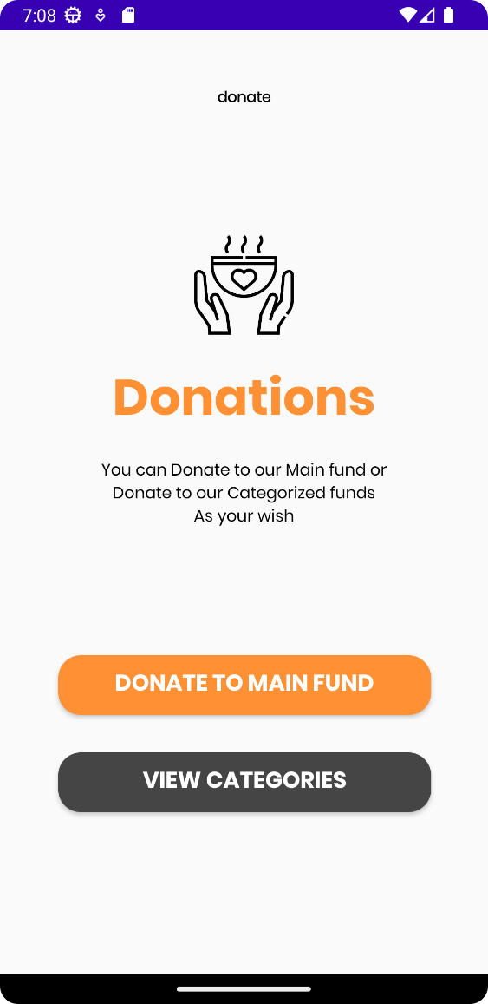

### 4.Donation Done

### 3.Donation Home

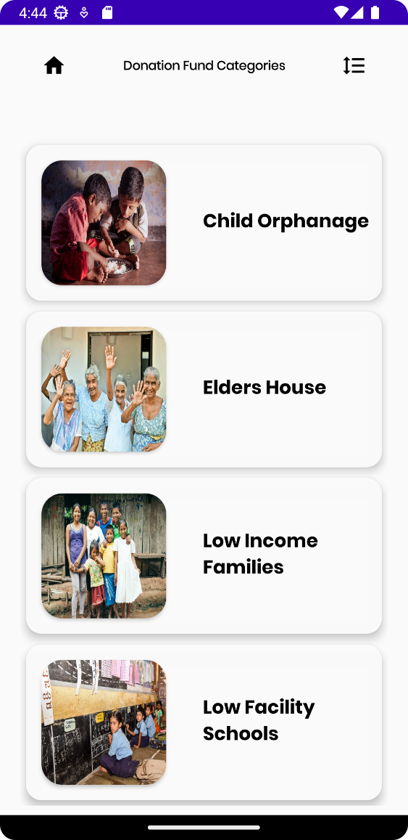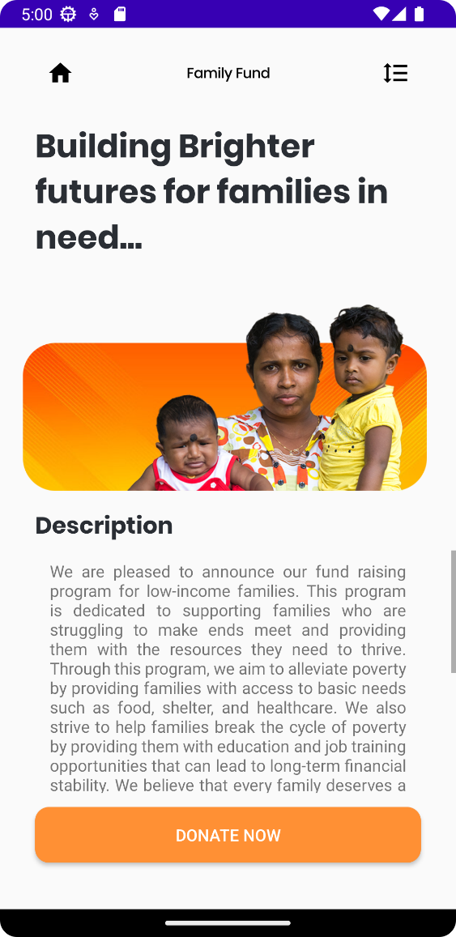

### 6.Donation 1

### 5.Donation Category

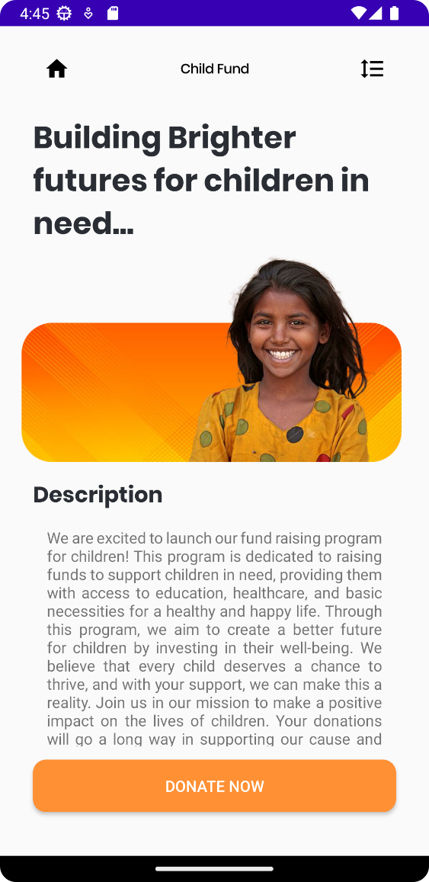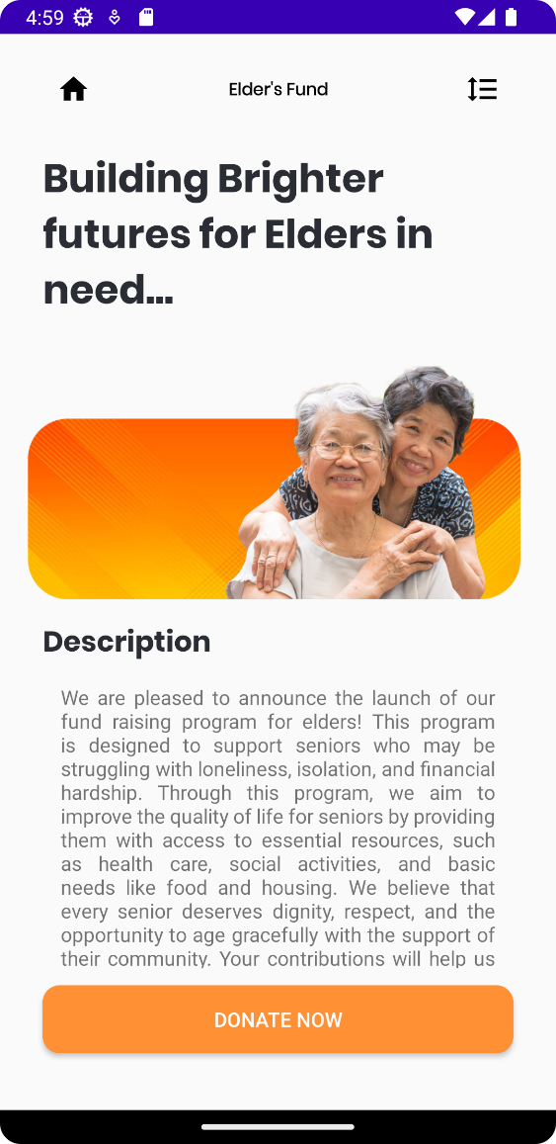

### 8.Donation 3

### 7.Donation 2

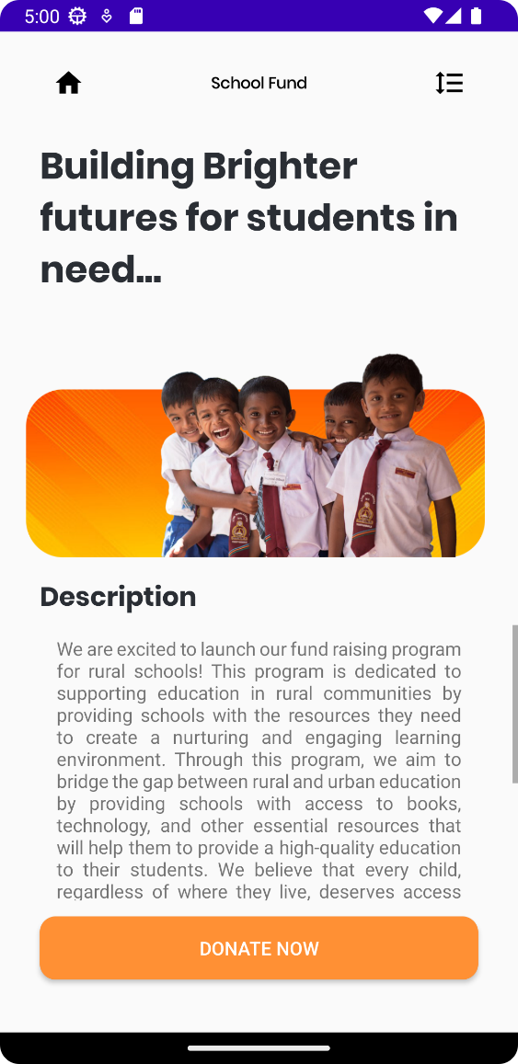

### 9. Donation 4

## IT21186042 – Family

### 2.Edit Family

### 1.Add Family

### 4.Delete Family

### 3.Contact Us

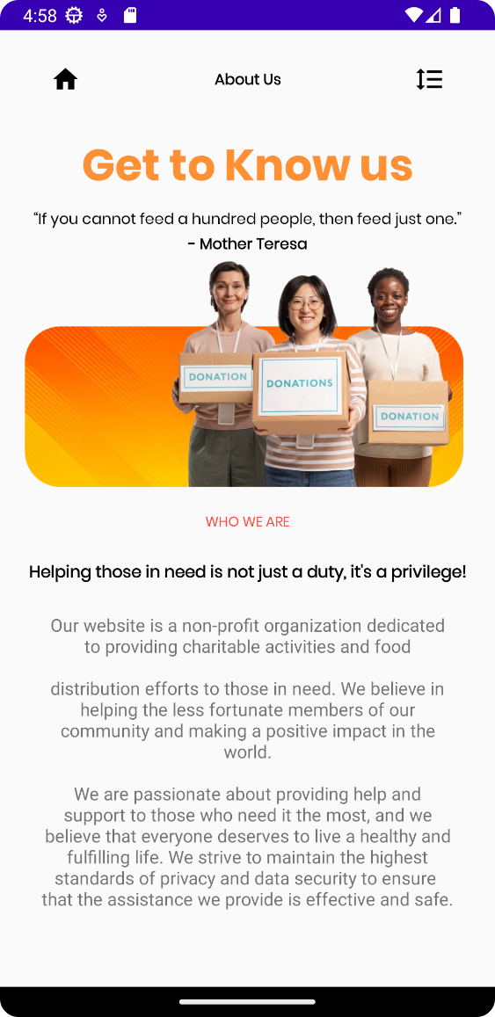

### 5.About Us

## IT21169144 – Article

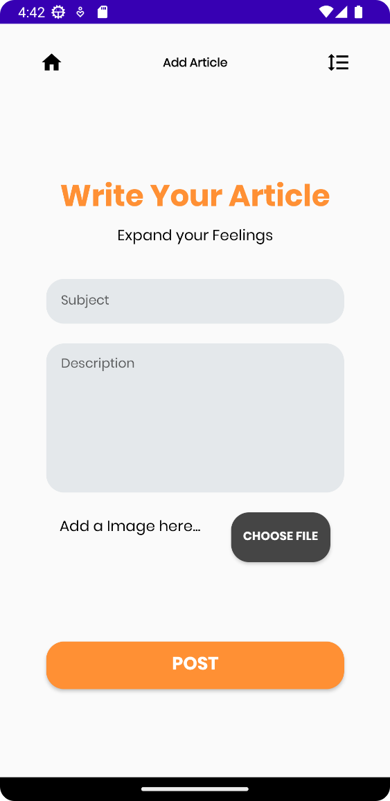

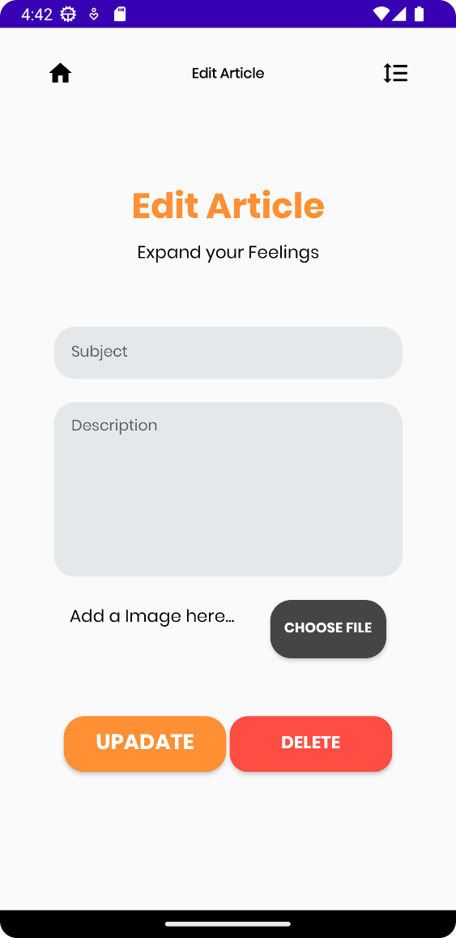

### 2.Edit/ delete Article

### 1.Add Article

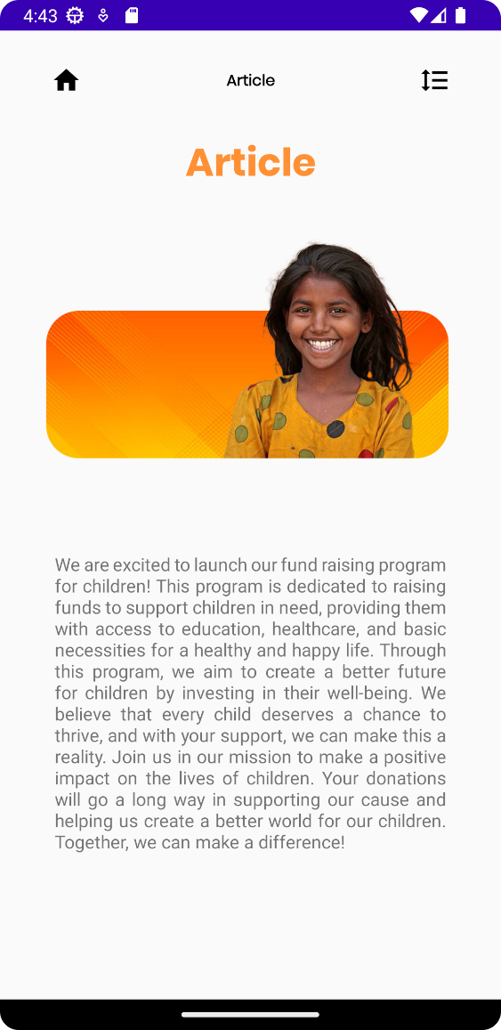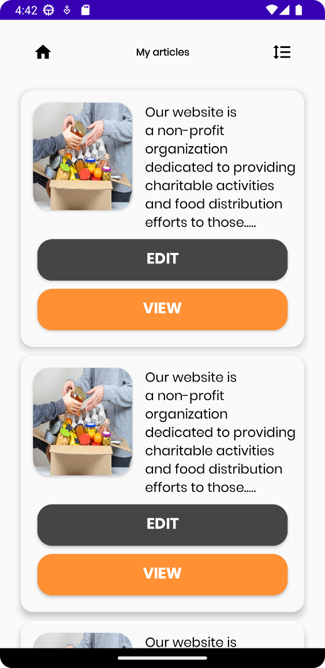

### 4.Article

### 3.View/edit Article

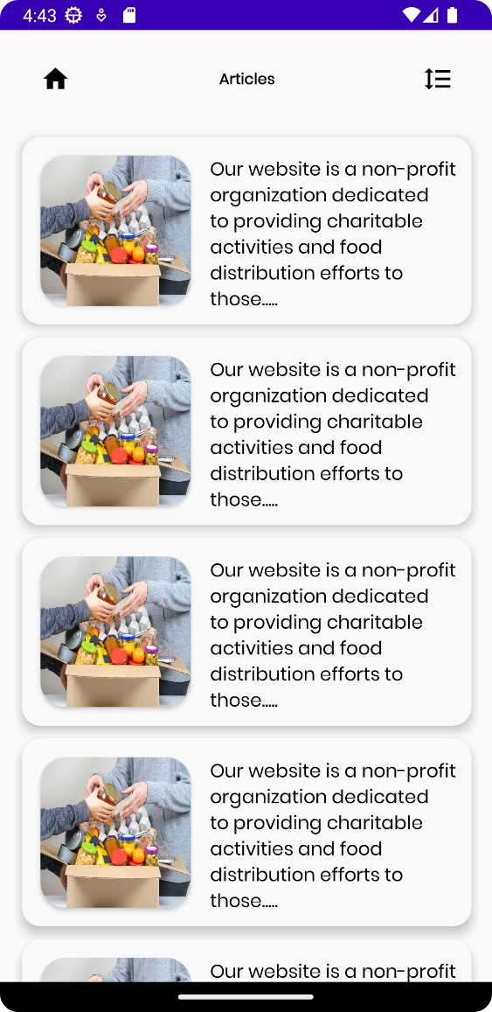

### 5.Article List

# Usage Of Resources

Git Hub Repo Link - <https://github.com/IsuruX98/MAD_Project_Neighbourly.git>

## Strings xml

### IT21169380 – User Profile and Donations

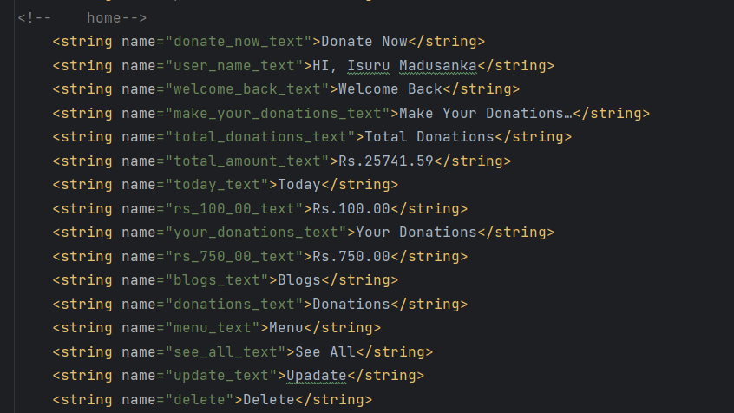

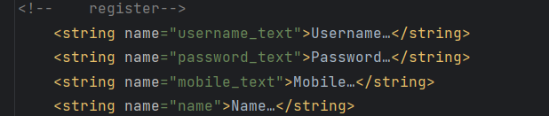

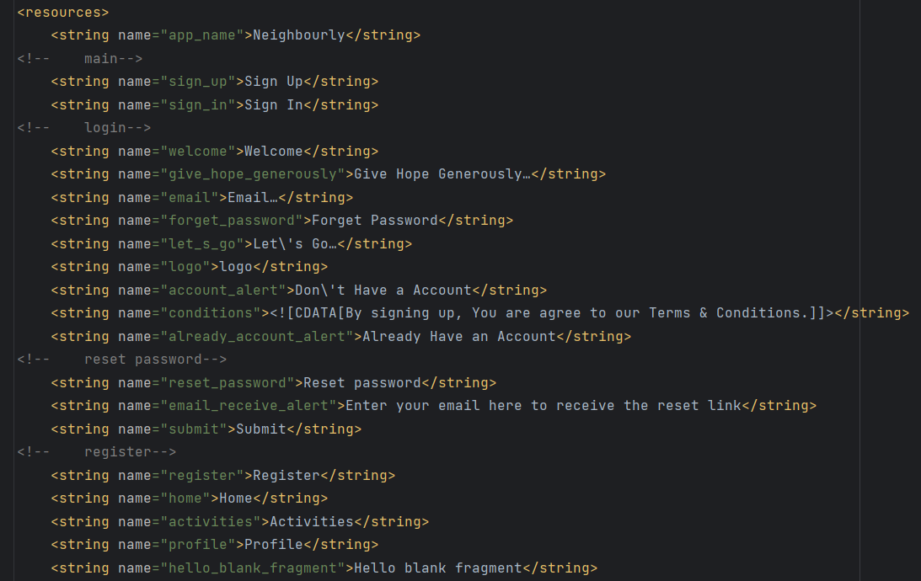

. IT21189944 – Item Donations

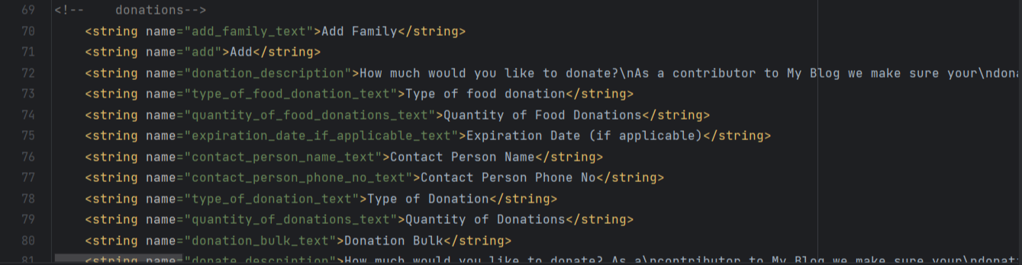

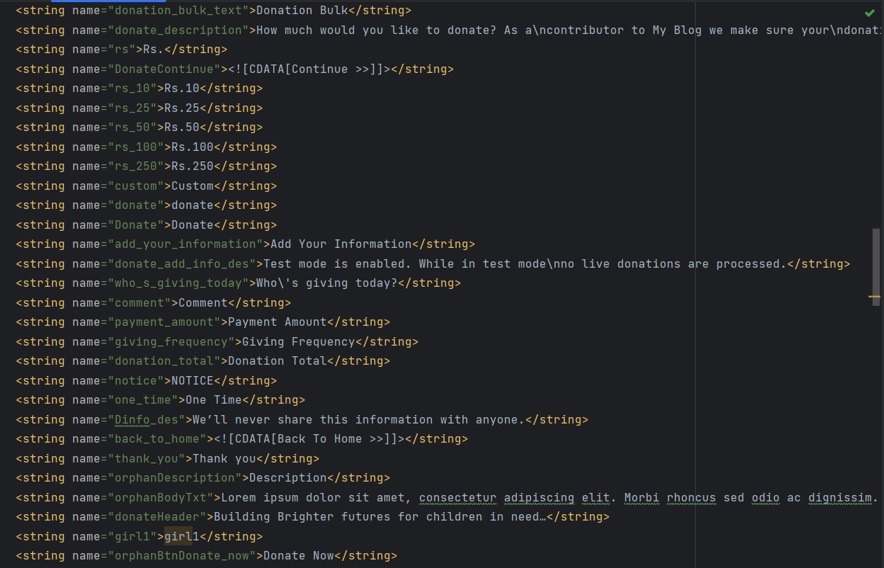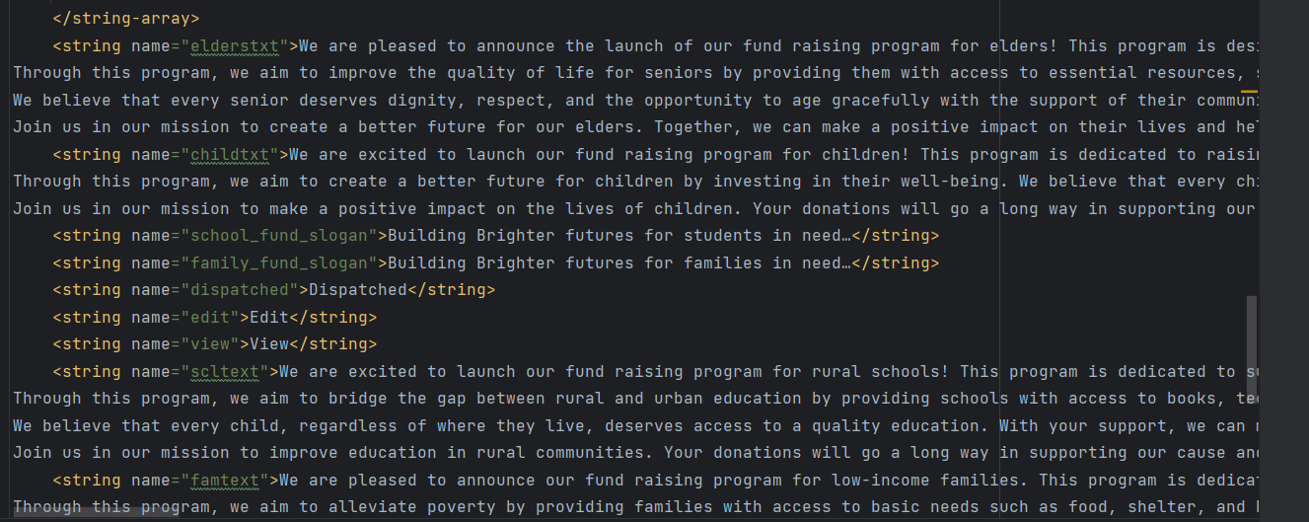

### IT21186042 – Family

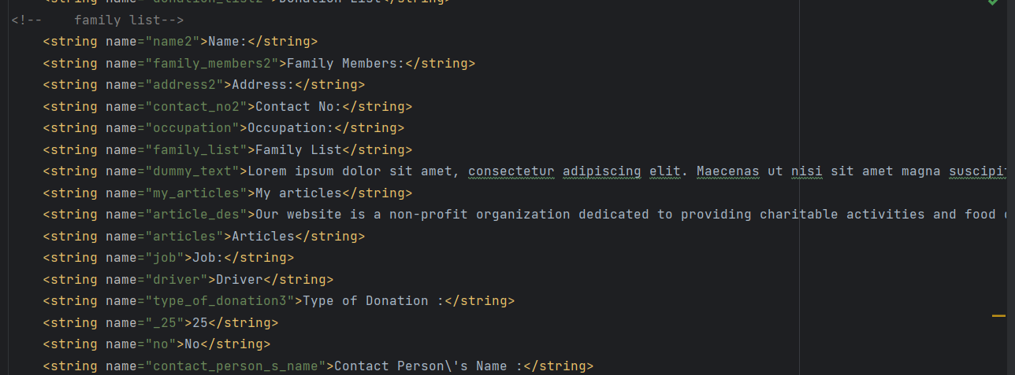

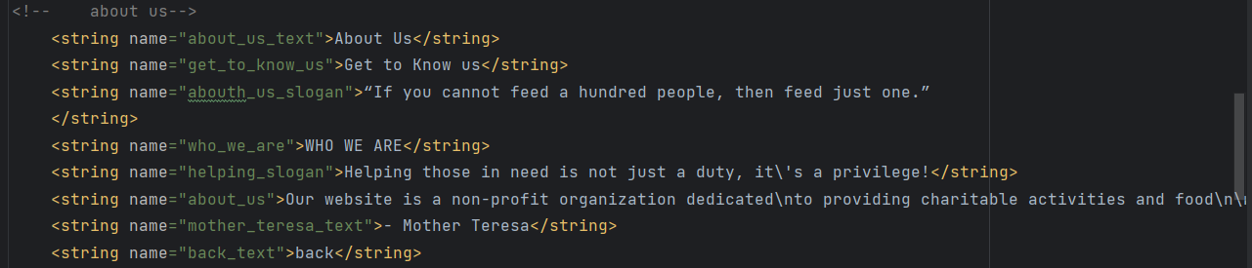

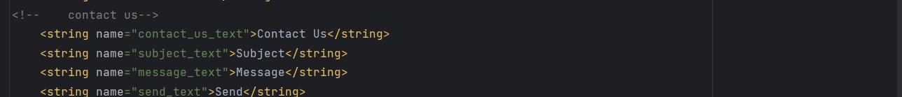

### IT21169144 – Article

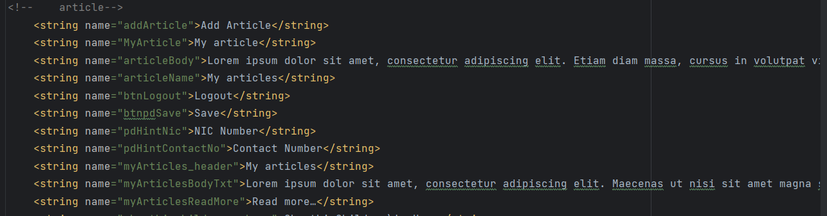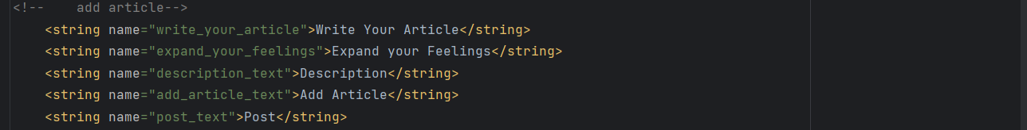

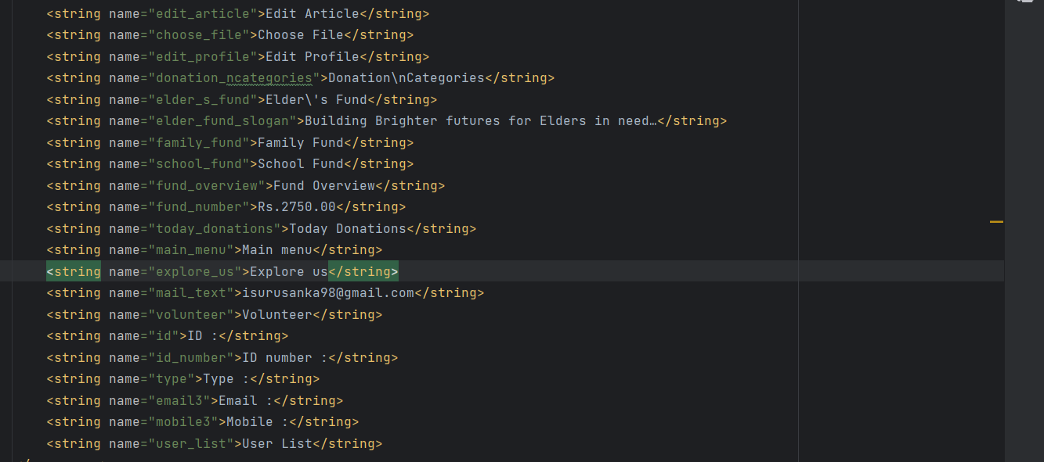

## Colors XML

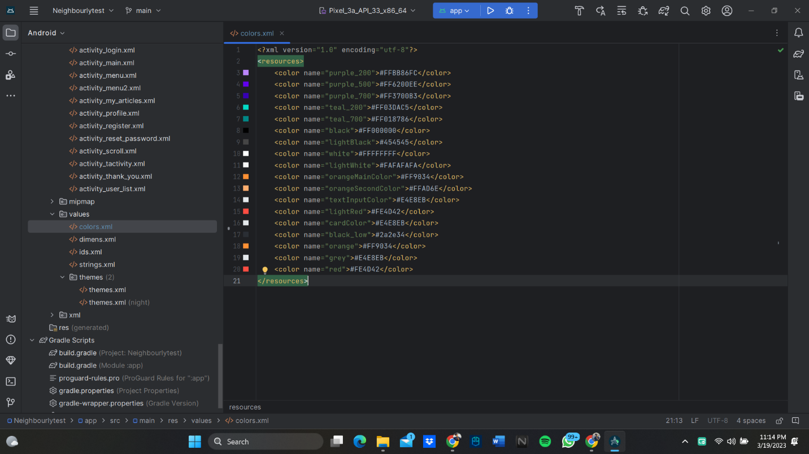

## Dimensions

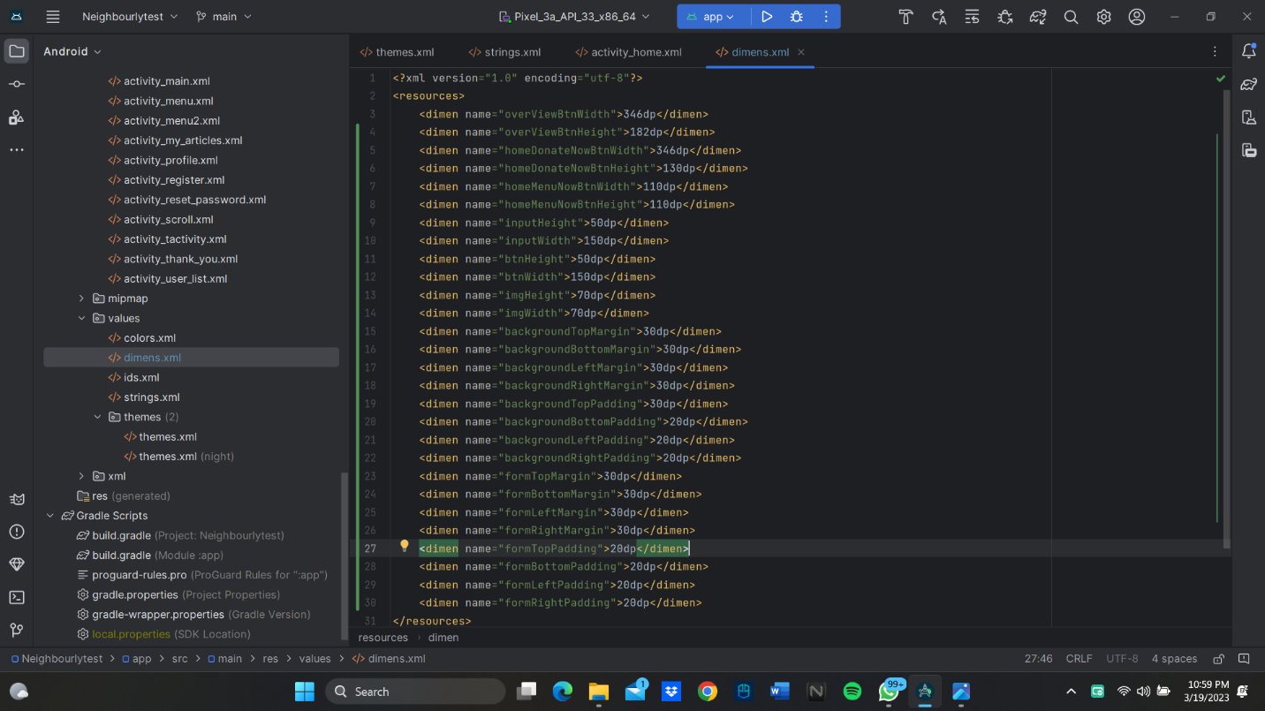

## Styles XML

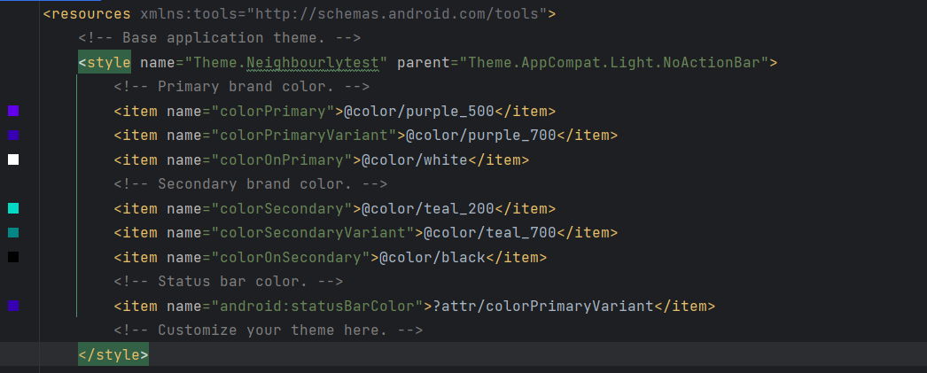

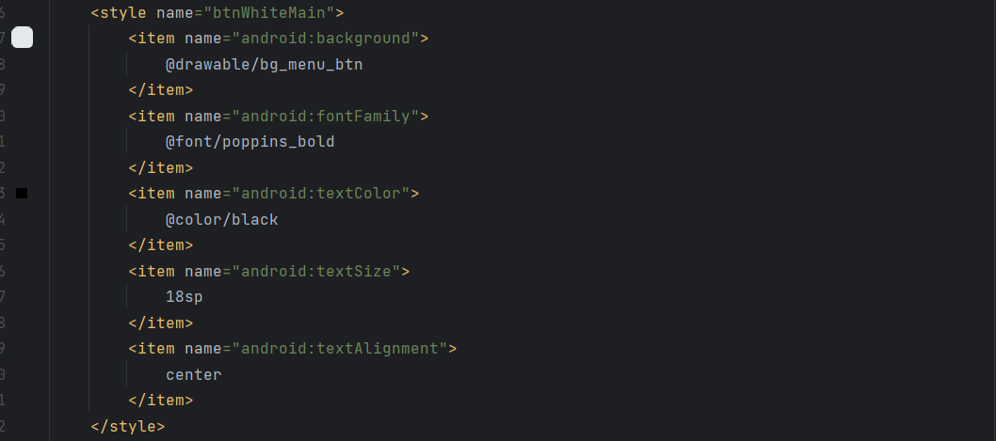

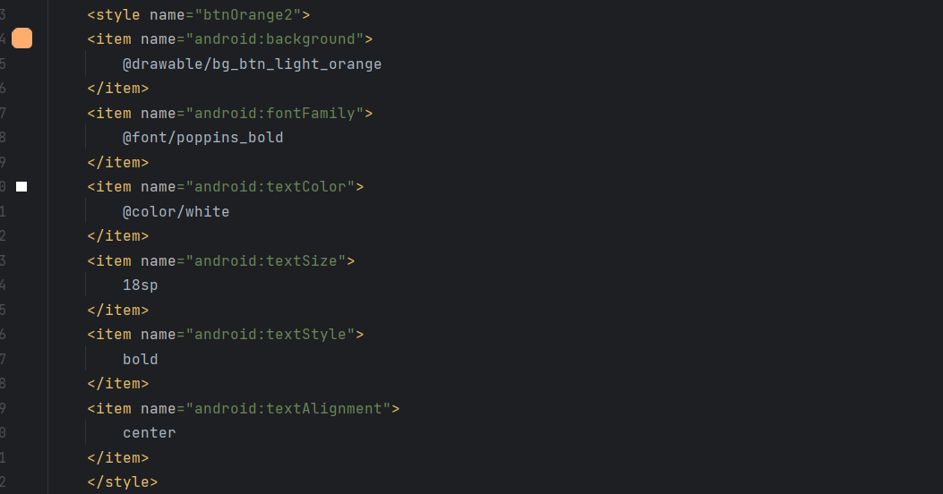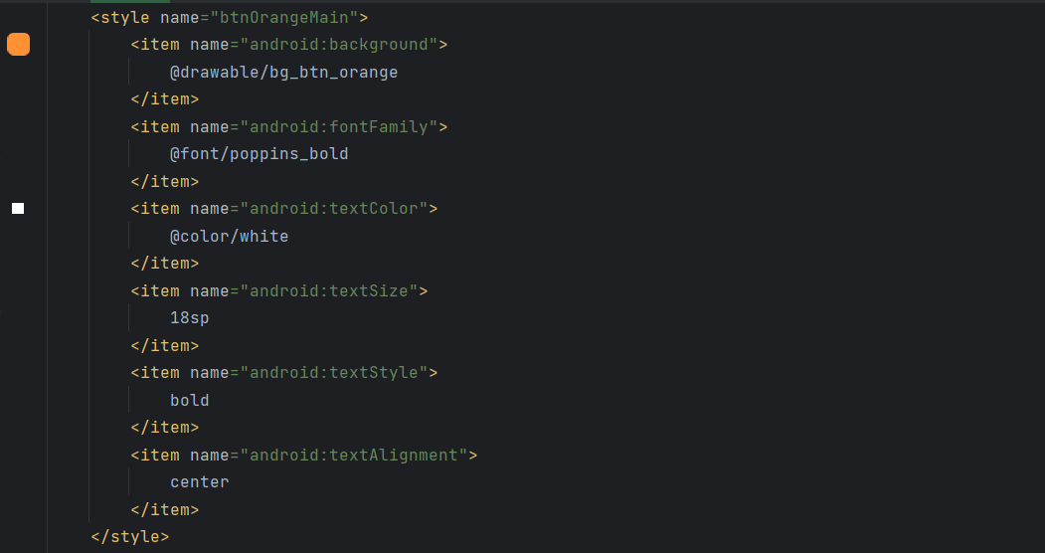

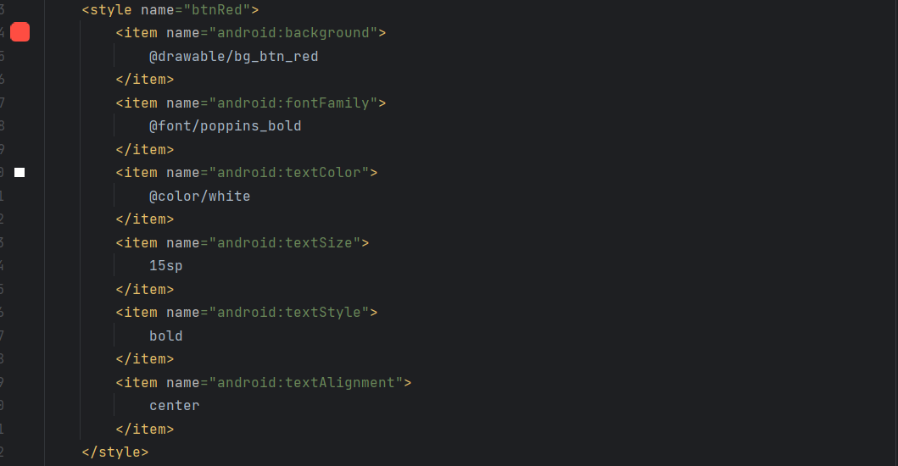

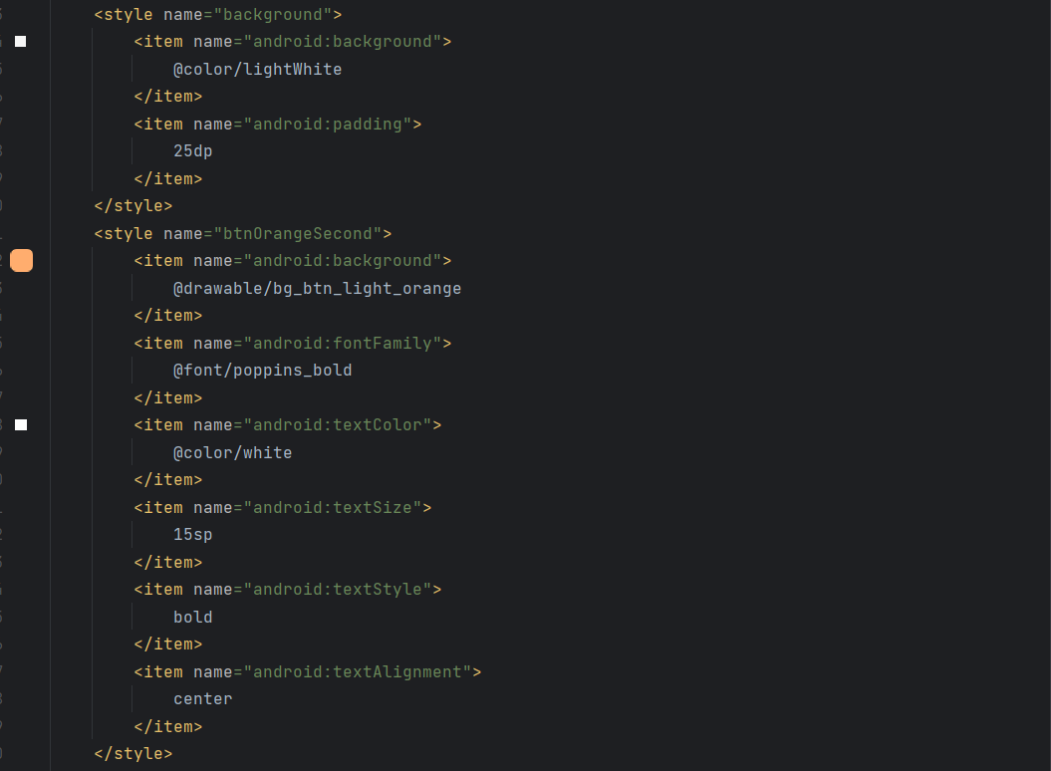

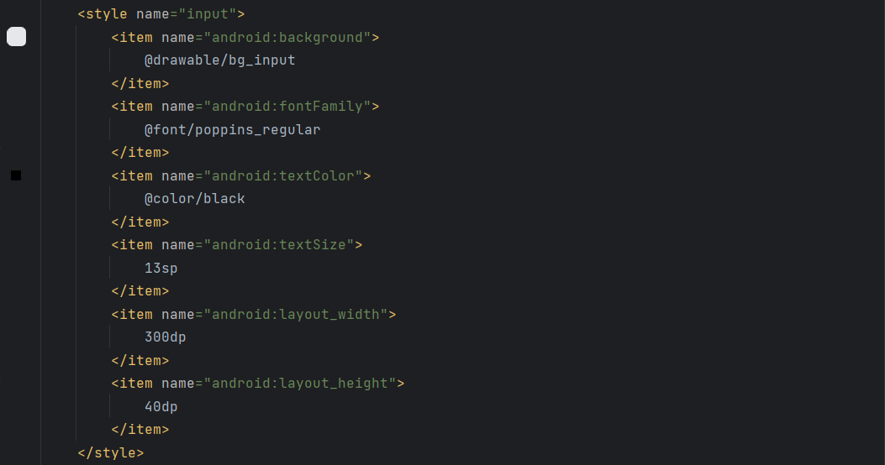

Git Hub Repo Link - <https://github.com/IsuruX98/MAD_Project_Neighbourly.git>

Drive Link for Android studio UI Screenshots with design view and layout validations - <https://drive.google.com/drive/folders/1p9x39Px6Lk8AhBFbSZuubSIhwalPx2fJ?usp=share_link>